ConfigSync
Distributed Configuration Management Service

Project Documentation
System Design Case Study

Flask • SQLite • Python • SSE
Leader Election • Replication • Consensus
Version Control • Rollback • Heartbeat Monitoring

1. Problem Statement
Modern organizations rely on distributed systems and microservice-based architectures where multiple services require access to shared configuration data such as database connection strings, API keys, feature flags, authentication tokens, and service endpoints.

Managing these configurations manually across multiple services introduces several challenges:

- Configuration inconsistencies between services
- Delayed propagation of updates
- Service downtime during configuration changes
- Lack of version control and audit history
- Difficulty in rolling back incorrect configurations
- Single points of failure in centralized systems

The objective of ConfigSync is to design and implement a distributed configuration management platform that provides centralized configuration storage, real-time synchronization, version control, fault tolerance, and configuration rollback capabilities while demonstrating key distributed system concepts such as leader election, replication, heartbeat monitoring, and consensus management.

2. Proposed Solution
ConfigSync provides a centralized platform for storing and managing configuration data across distributed services.

The proposed solution consists of:

- A Flask-based backend application
- SQLite-based configuration storage
- Real-time synchronization using Server-Sent Events (SSE)
- Distributed node cluster simulation
- Leader election mechanism
- Configuration replication
- Heartbeat monitoring
- Configuration versioning
- Point-in-time rollback support
- Interactive monitoring dashboard

Whenever an administrator creates or updates a configuration, the leader node coordinates replication across follower nodes. Once a quorum is achieved, the update is committed and propagated to all connected services.

This architecture ensures consistency, fault tolerance, and high availability while allowing services to receive updates without requiring restarts.

3. System Architecture

Architecture Flow
- Administrator submits configuration updates.
- Flask API validates requests.
- Configuration Store saves data.
- Leader Node initiates replication.
- Followers synchronize configurations.
- Watch Service broadcasts events.
- Connected services receive updates.
- Monitoring Engine tracks cluster health.

High-Level Architecture
Admin Dashboard
|
v
Flask API Layer
|
+----+----+----------+
v v v
Config Watcher Monitoring
Store Service Engine
|
v
SQLite Database
|
v
Distributed Node Cluster
Leader Node
|
+-------+-------+
v v v
Follower Follower Follower
|
v
Connected Microservices

4. Module Description

Admin Dashboard
Provides a graphical interface for managing configurations and monitoring cluster status.

Responsibilities
- Create configurations
- Update configurations
- Delete configurations
- Rollback revisions
- Monitor distributed nodes

Flask API Layer
Acts as the communication layer between users and the distributed system.

Responsibilities
- Request handling
- Input validation
- API routing
- Event triggering

Configuration Store
Stores active configuration records.

Responsibilities
- Create configurations
- Update configurations
- Delete configurations
- Version tracking

Watcher Service
Provides real-time notifications.

Responsibilities
- Event streaming
- Change detection
- Configuration propagation

Distributed Node Cluster
Simulates a distributed environment.

Components
- Leader Node
- Follower Nodes
- Candidate Nodes

Responsibilities
- Leader election
- Replication
- Consensus management

Monitoring Engine
Tracks cluster health.

Responsibilities
- Heartbeat monitoring
- Failure detection
- Status visualization

5. Database Design
The system uses SQLite to store configurations, version history, and service information.

Table: configurations
Field | Type | Description
id | INTEGER | Primary Key
key | TEXT | Configuration Key
value | TEXT | Configuration Value
description | TEXT | Description
version | INTEGER | Version Number
updated_at | DATETIME | Last Updated

Table: config_history
Field | Type | Description
id | INTEGER | Primary Key
config_id | INTEGER | Configuration Reference
action | TEXT | CREATE / UPDATE / DELETE / ROLLBACK
version | INTEGER | Revision
timestamp | DATETIME | Change Time

Table: services
Field | Type | Description
node_id | TEXT | Service Identifier
role | TEXT | Leader / Follower
status | TEXT | Alive / Dead
heartbeat | INTEGER | Last Heartbeat
current_version | INTEGER | Synced Revision

6. Technology Stack
Category | Technologies
Frontend | HTML5, CSS3, JavaScript
Backend | Python, Flask
Database | SQLite
Distributed Concepts | Leader Election, Replication, Consensus, Heartbeat Monitoring, Fault Tolerance, Event Streaming, Version Control
Tools | VS Code, Git, GitHub, Draw.io

7. Implementation Details

Configuration Management
The administrator creates configurations using the dashboard. Example request payload:

{
"key": "database_url",
"value": "postgresql://localhost:5432/app"
}
The configuration is stored in the database and assigned a version number.

Leader Election
The system simulates a Raft-like consensus mechanism with three node states:

- LEADER — coordinates all writes and replication
- FOLLOWER — replicates from leader; monitors heartbeat
- CANDIDATE — initiates election when leader heartbeat is lost

If the leader fails, followers detect the missing heartbeat, transition to CANDIDATE state, and hold a new election to select a replacement leader.

Replication
When a configuration is updated:

- Leader receives update.
- Database stores revision.
- Followers replicate change.
- Quorum validates commit.
- Update becomes globally available.

Heartbeat Monitoring
Each node periodically updates its heartbeat information. Benefits include:

- Failure detection
- Cluster health monitoring
- Automatic recovery

Rollback
Rollback restores the system to a previous revision. Benefits:

- Disaster recovery
- Error correction
- Audit support

Watch Service
Implemented using Server-Sent Events (SSE). Benefits:

- Real-time updates
- Low latency synchronization
- Event-driven architecture

8. Screenshots

Screenshot 1 – Dashboard Overview
The main dashboard displays real-time cluster status including total configurations, connected services, current consensus term (Raft election term), active leader node, and global revision number. The header prominently shows the consensus state (Healthy – Quorum Active), the active leader (Service C), and the current global revision.

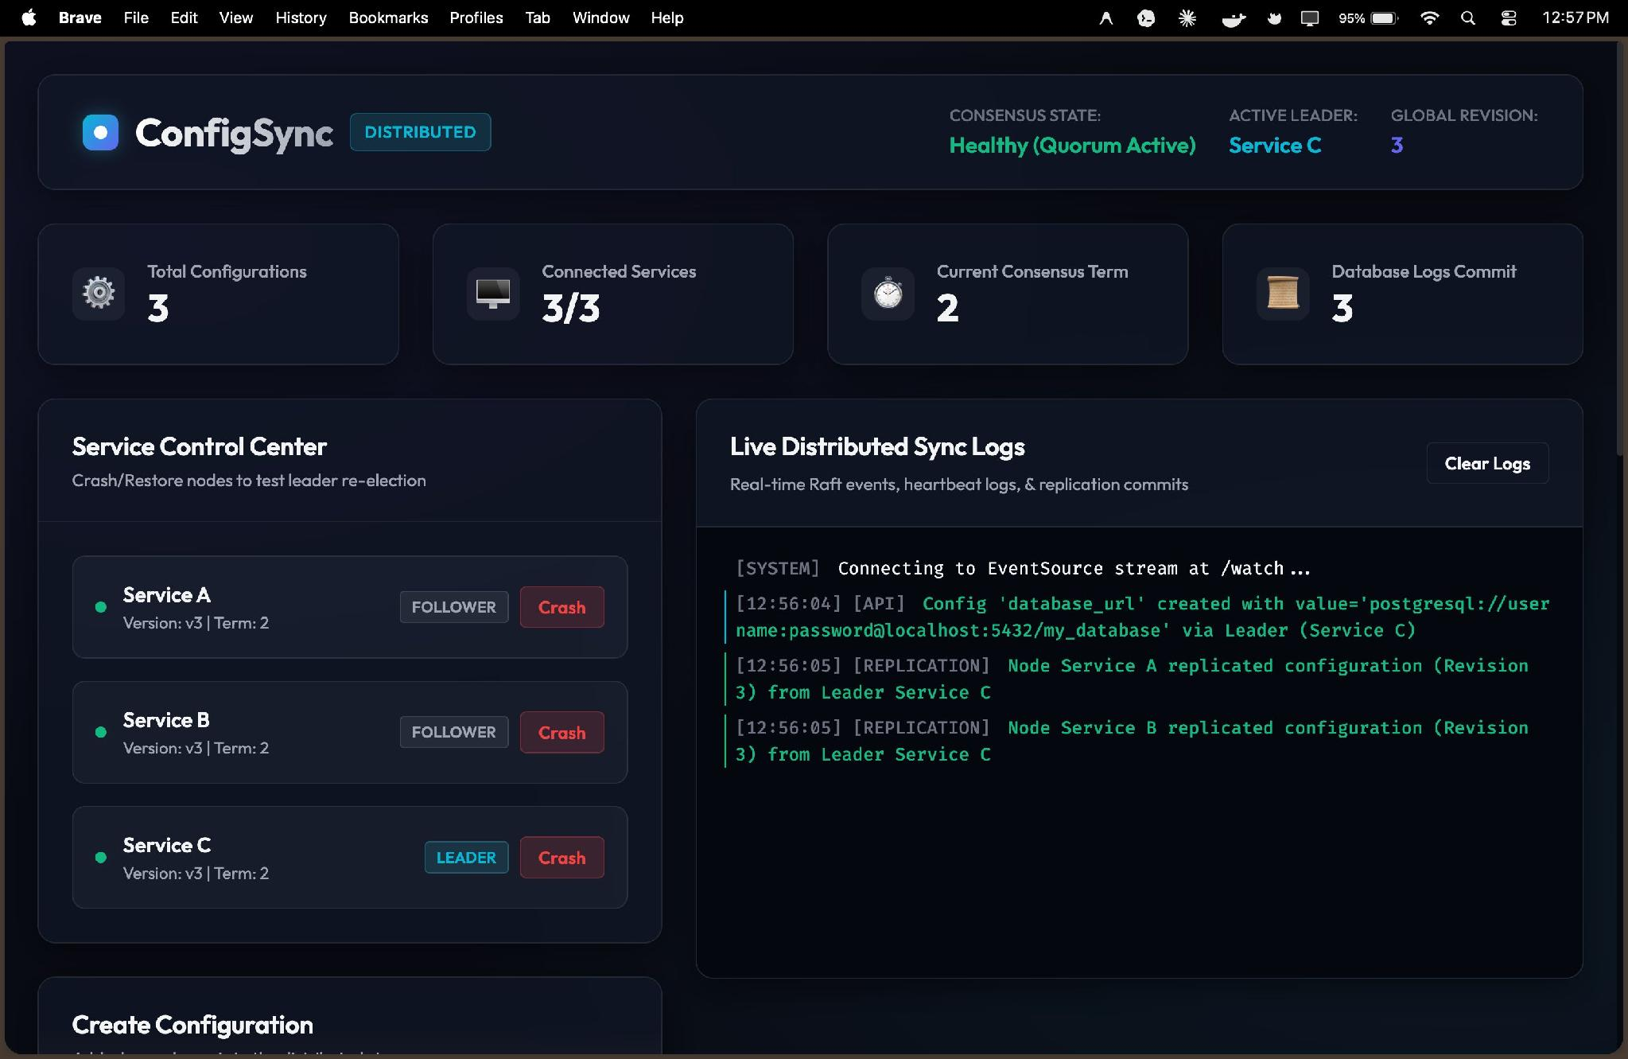
Figure 1: ConfigSync Dashboard – Service Control Center & Live Distributed Sync Logs

Key metrics visible in the dashboard:

Total Configurations | 3 active configuration entries stored

Connected Services | 3/3 – all nodes online

Current Consensus Term | 2 – current Raft election term

Database Logs Commit | 3 – global revision committed

The Service Control Center panel (left) shows all three nodes – Service A and Service B as FOLLOWERS and Service C as the LEADER – each running on version v3, Term 2. The Live Distributed Sync Logs panel (right) shows real-time replication events including the creation of the database_url configuration and its subsequent replication to follower nodes.

9. Future Scope
The current implementation demonstrates core distributed system concepts. Future enhancements may include:

- Full Raft Consensus Implementation
- Multi-Region Replication
- Docker Deployment
- Kubernetes Integration
- Role-Based Access Control (RBAC)
- JWT Authentication
- Prometheus Monitoring
- Grafana Dashboards
- Cloud Deployment on AWS / Azure / GCP
- Distributed Cache Integration
- High Availability Clusters

10. Conclusion
ConfigSync successfully demonstrates the design and implementation of a distributed configuration management service. The system provides centralized configuration storage, real-time synchronization, leader election, replication, fault tolerance, version control, and rollback capabilities.

The project effectively applies distributed systems concepts inspired by Apache ZooKeeper and etcd while providing a practical and interactive platform for understanding modern configuration management architectures. This implementation fulfills the requirements of the System Design case study and serves as a scalable foundation for future enhancements.

